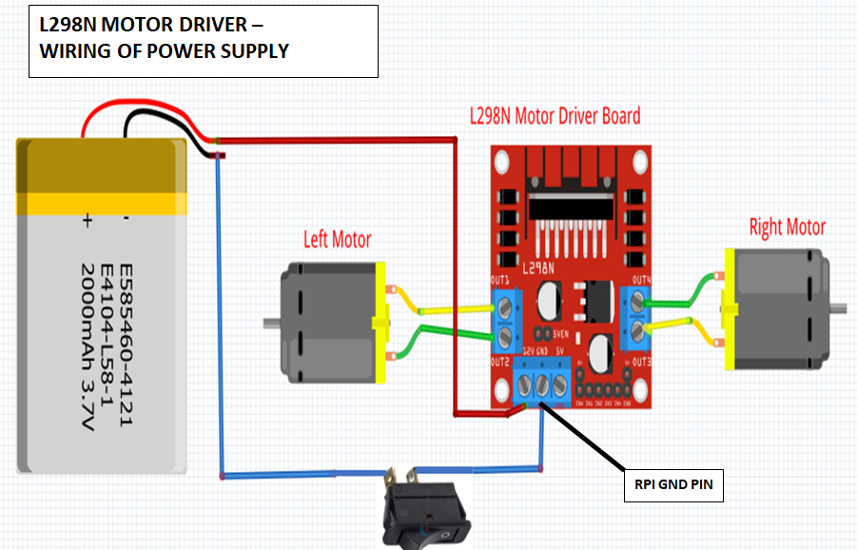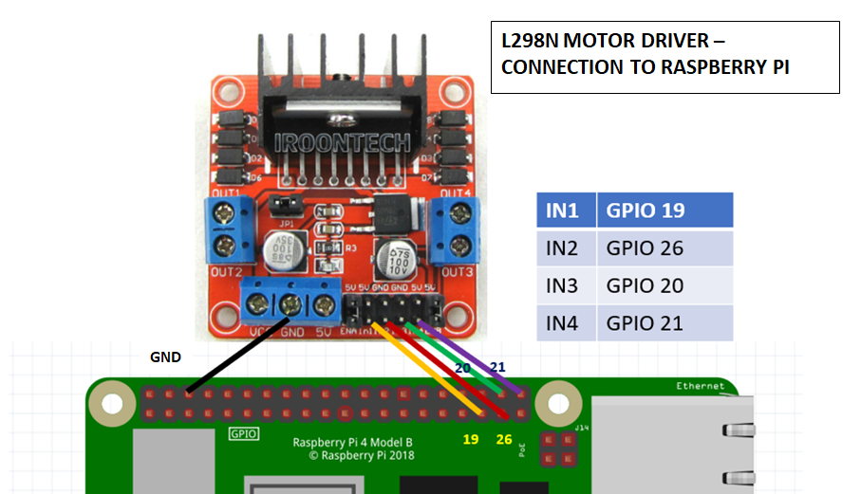

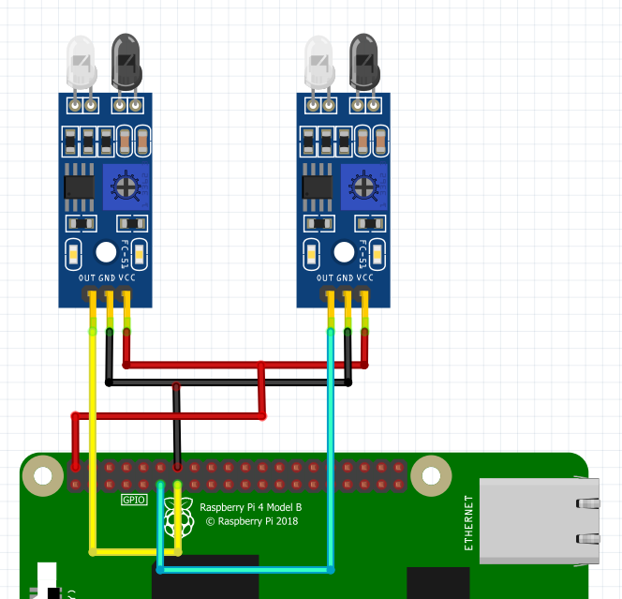

**LEFT SENSOR -> 27**

**RIGHT SENSOR > 17**

**WIRING DIAGRAM FOR LINE SENSOR**

**GPIO 17**

**GPIO 27**

**#import libraries**

**from gpiozero import Robot,LineSensor**

**from time import sleep**

**#setup**

**robby = Robot(left=(19,26), right=(20, 21))**

**leftSensor = LineSensor(27)**

**rightSensor = LineSensor(17)**

|  |  |  |  |  |  |  |  |  |  |
| --- | --- | --- | --- | --- | --- | --- | --- | --- | --- |
| Left | Right |  |  |  |  |  |  |  |  |
| Sensor | Sensor |  |  |  |  |  |  |  |  |
| 0 | 0 |  | Both Sensors **NOT** sensing the black line | | | |  |  |  |
|  |  |  |  |  |  |  |  |  |  |
| 0 | 1 |  | Right Sensor senses black line | | | |  |  |  |
|  |  |  |  |  |  |  |  |  |  |
| 1 | 0 |  | Left Sensor senses black line | | | |  |  |  |
|  |  |  |  |  |  |  |  |  |  |
| 1 | 1 |  | Both Sensors sense black line | | | |  |  |  |
|  |  |  |  |  |  |  |  |  |  |

**Hint:**

**if leftSensor == 0 and rightSensor == 0:**

**robby.forward(.2)**

**You will need a while True loop**